**KUBERNETES**

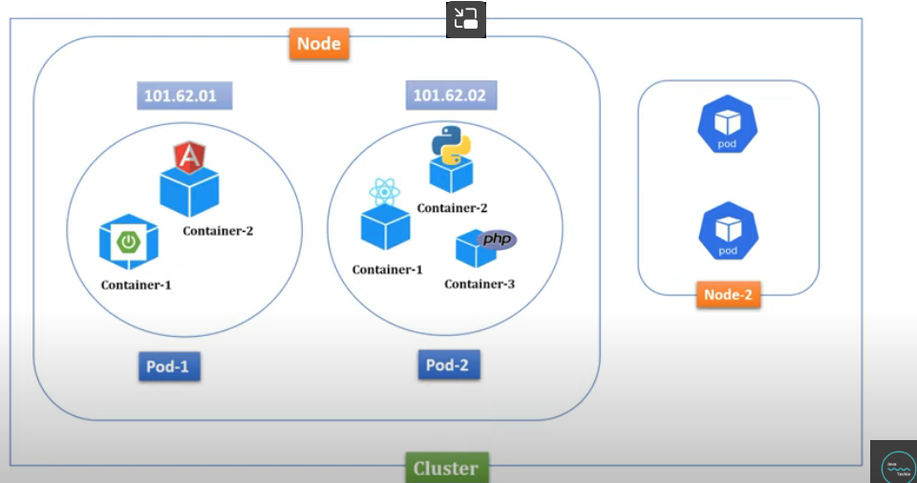

To run Kubernetes we need to setup a cluster on pur machine which cn be set by using the miniquobe.

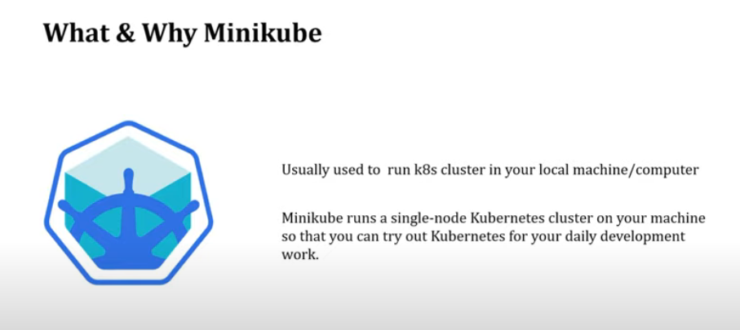

KUBECTL

Using kubectl we can connect to a Kubernetes cl;uster from our windows machine

Install kubectl

**MINIKUBE**

Now download minikube for windows

After downloading it rename it to minikube.exe

3.Make a folder in C:

And plzce the above two exe files inthat.

Now to access this kubectl we need to add the above path to environment variable

Now add it to path

Environment .

4.Now check the minikube version

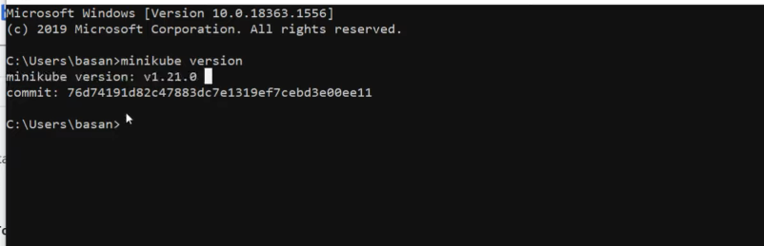

Now you are done with the minikube setup in windows

5. **start a minikube**

You can use hyper v or virtual box.

For windows you need to use above two

If you have docker installed on your machine then you can use docker to start mininkube

Check minikube status

Check minikube status

As per the documentation once we start the minicube it will run a single node cluster

To verify if it made acluster or not

The aove is clustedr nfo

Now get node info

Now we are done with the Kubernetes sertup.now we go with deployment

As next step we will have to dockerize our application.we need to create a docker image of our application and push it to docker hub.

Now Kubernetes cluster will pick the image up from the docker hub and run it.

We will tell minikube the environment

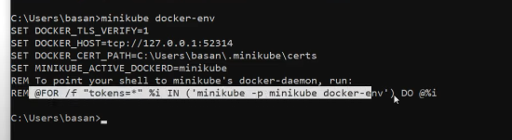

Now Kubernetes can read your local docker repeo

Now we want to see the docker images

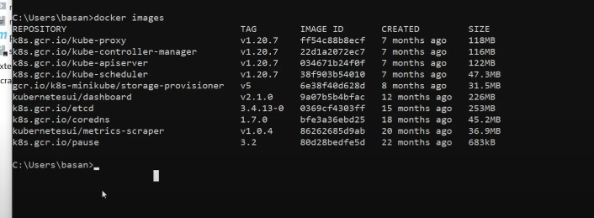 we can also see the Kubernetes specific images also.

Now do a cd to your application directory(springboot application dir)

As we need to build a docker image

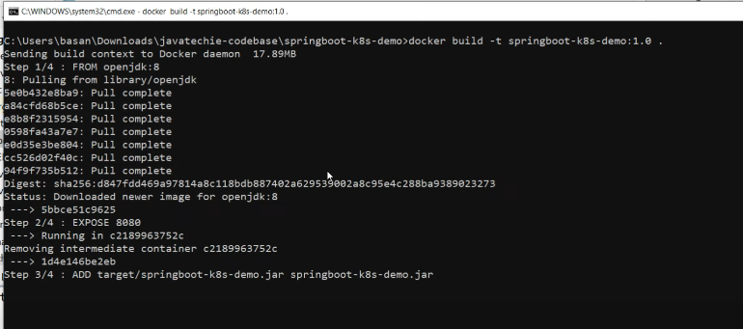

The above created the docker image

Now to check we can do docker images

And we will get our docker image there.

Now we want to run the above image inside a pod.

We need to create a deployment object.

Deployments are Kubernetes objects that are used for managing the pods.

We will make deployment object using cmd

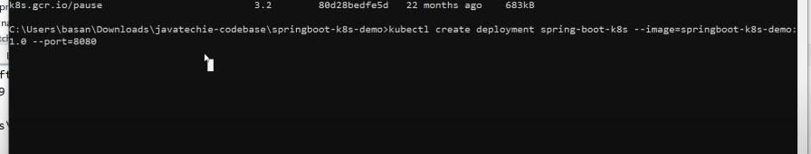

We are telling kubectl create a deployment object named as – and take image from image and it is running on port 8080



**Now we can get all the deployments**

**Describing a deployment**

We can get all the pods and also when we get the pod we can get the logs of that pod

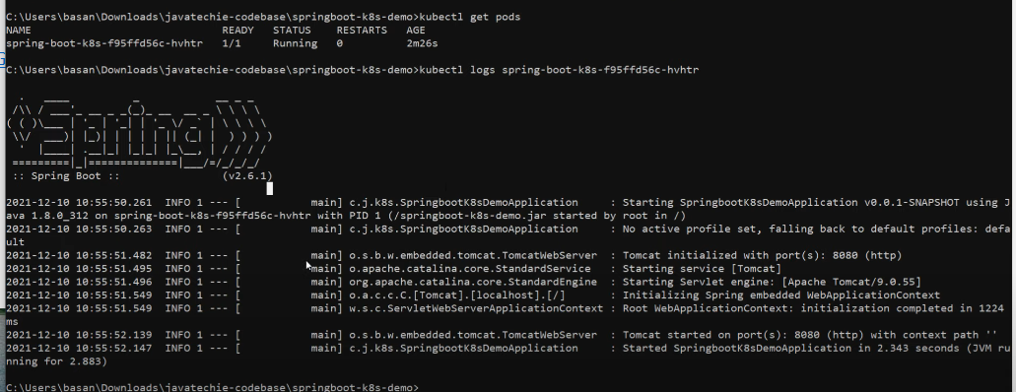

Now we will create a service object from our deployment

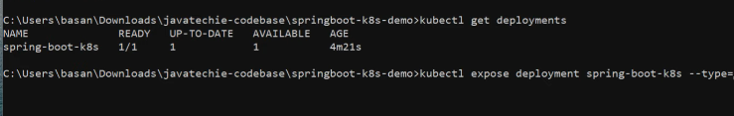

Now from the service we can get a url to access our service

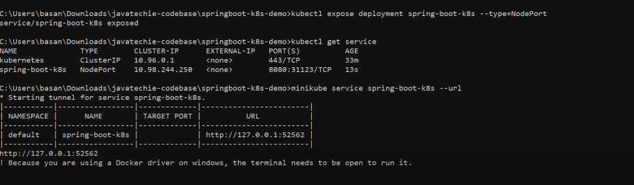

Copy the urla dn run it.

Now we are able to access our pods running in a Kubernetes cluster

Now you can see the metrics with dashboard

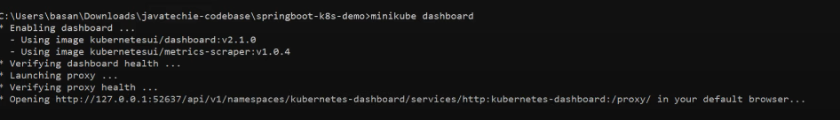

Use the above url and access.

[Kubernetes Tutorial | Setup Kubernetes in Windows & Run Spring boot application on k8s cluster | by Java Techie | Medium](https://medium.com/@javatechie/kubernetes-tutorial-setup-kubernetes-in-windows-run-spring-boot-application-on-k8s-cluster-c6cab8f7de5a)